DEFINITION OF PERFORMANCE STANDARD

PERFORMANCE STANDARDS

Performance Standards are the establishment of organizational or system standards, targets, and goals to improve organization practices..  Standards may be set based on national, state, or scientific guidelines, benchmarking against similar organizations, the public’s or leaders’ expectations, or other methods

EXAMPLE OF PERFORMANCE STANDARD

PUBLIC HEALTH ORGANIZATION

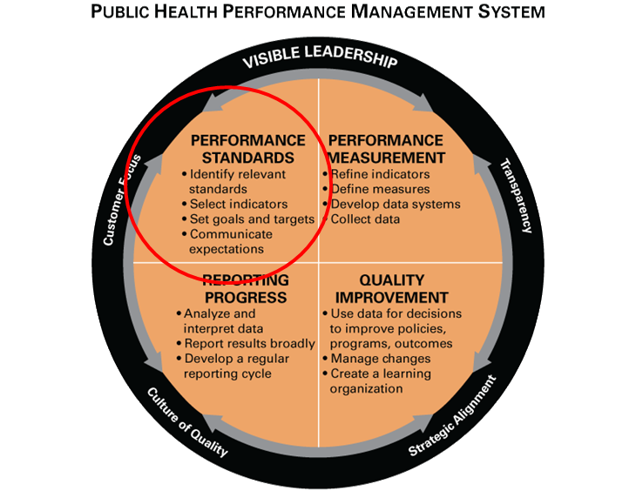

**ELEMENTS OF ESTABLISHING PERFORMANCE STANDARDS**

Based on the position, not the individual

Observable, specific indicators of success

Meaningful, reasonable and attainable

Describe "fully satisfactory" performance once trained

Expressed in terms of Quantity, Quality, Timeliness, Cost, Safety, or Outcomes

**IMPORTANCE OF PERFORMANCE STANDARDS**

Employee participation in a company's method to improve organizational success is an essential element, and the main measure of an employee's involvement should be the establishment of performance standards. By creating a systematic set of performance standards, employees can be objectively evaluated as to their contribution to the overall mission and goals of the company. Not only can the performance of employees be evaluated according to a set of standards, but other influences on evaluations, such as personal feelings or general popularity, can be eliminated. Performance management can be defined as the "systematic process by which an agency involves its employees, as individuals and members of a group, in improving organizational effectiveness in the accomplishment of agency mission and goals." ("Performance Management") Therefore, since employee participation is essential for the success of the entire company, organization, or agency, it is imperative to create a set of standards by which employee participation and success can be measured. Without such a set of standards, it is impossible to accurately measure the effectiveness of employees in regards to their participation in accomplishing the overall goals of the company. But when it comes to performance standards, the expectations must be clearly communicated to the employee, and management must observe, provide feedback, and conduct appraisals which enable them "to achieve the

**DEFINING THE EMPLOYEE’S GOALS AND WORK STANDARDS**

The idea that the employee’s effort should be goal directed is central to performance management and appraisal. Managers should appraise employees based on the specific standards by which the employees expected to be measured. And, the employee’s goals and performance standards should make sense in terms of the company’s strategic goals.

In practice, clarifying what you expect from employees is trickier than it may appear. Job descriptions are rarely the answer. Employers usually write job descriptions not for specific jobs, but for groups of jobs, and the descriptions rarely include specific goals. Your sales manager‟s job description may list duties like “supervise salesforce”. But, for strategic purposes, you may expect your sales managers to personally sell at least $600,000 worth of products per year by handling the division‟s two largest accounts; and to keep the salesforce happy

The most straightforward way to do this (for the sales manager job above, for instance) is to set measurable standards for each objective. You might measure the “personal selling” activity in terms of how many dollars of sales your manager is to generate personally; perhaps measure “keeping the salesforce happy” in terms of turnover (on the assumption that less than 10% of the salesforce will quit in any given year if morale in high). Guidelines for effective goal setting include the following

a) Assign specific goals – employees with specific goals usually perform better.

b) Assign measurable goals – Express goals in quantitative terms and include target dates or deadlines. Goals set in absolute terms (such as “an average daily output of 300 units”) are less confusing than goals set in relative terms (such as “improve production by 20%). If measurable results will not be available, then “satisfactory completion” – such as “satisfactorily attending workshop” or satisfactorily completed his or her degree” – is the next best thing. In any case, always include target dates or deadlines

c) Assign challenging but Doable goals. Goals should be challenging, but not so difficult that they appear impossible or unrealistic d) Encourage Participation.